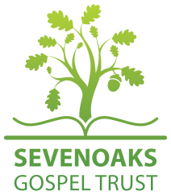**Sevenoaks Gospel Trust Grant Making Policy**

The Objects of the Sevenoaks Gospel Trust are to advance the evangelical Christian faith, including (but without limitation) by providing grants or other funding to, and making available property for use by, churches and other Christian charities or groups in particular in the Sevenoaks area that are in sympathy with the Statement of Faith adopted by the Sevenoaks Gospel Trust. This policy covers only grant making or other funding activity.

In accordance with their duty to ensure that charitable funds are used to further the Objects of Sevenoaks Gospel Trust, the trustees will prioritise grant making or other funding for the following purposes:

1. Operational or capital expenditure of St Nicholas church, Sevenoaks (“St Nicholas”) in connection with any new initiative, for example a new church plant, outreach campaign or staff position;
2. To cover a shortfall of income over expenditure of St Nicholas in relation to its regular ministry;
3. To support the ministry of other evangelical churches or Christian groups or charities in the Sevenoaks area;
4. To support the ministry of other evangelical churches or Christian groups or charities in the Kent or surrounding area.

Provided always that any grants or loans will be made only to bodies which subscribe to Sevenoaks Gospel Trust’s Statement of Faith.

Adopted 10 March 2023